# Miscellaneous

* Make Sure understand C
* Can convert binary to decimal and vice versa

# How C represents Signed Integers

1. Sign-and-Magnitude

First bit is sign bit

Remainder is magnitude

1. 1s complement

|  |  |
| --- | --- |
| Binary | n-bit 1s complement |
| +X | X |
| -X | 2n – X - 1 |

Example:

12 = (00001100)­2 = (00001100)­1s

-12 = 2n – X – 1 = 243 = (11110011)1s

Flip all the bits

Addition:

* Perform binary addition
* move last carry to result
* check overflow

1. 2s complement

|  |  |
| --- | --- |
| Binary | n-bit 2s complement |
| +X | X |
| -X | 2n – X |

Example:

3-bit

3 = (011)2 = (011)2s

-3 = 23 – 3 = 5 = (101)2s

Starting from the right, flip all the bits after the first 1

Addition:

* Perform binary addition
* Ignore the carry out
* Check overflow

1. Excess-k

Add K to a value x, to represent in binary

Excess-8

-8 => -8 + 8 = 0 = 0000

0 => 0 + 8 = 8 = 1000

# IEEE-754

For 32 bit

|  |  |  |
| --- | --- | --- |
| Sign bit | 1 bit | 0 = +ve, 1 = -ve |
| Exponent | 8 bit | Excess 127 |
| Mantissa | 23 bit | Nominalized to 1.x,  Mantissa is the x |

For 64 bit

|  |  |  |
| --- | --- | --- |
| Sign bit | 1 bit |  |
| Exponent | 11 bit |  |
| Mantissa | 52 bit |  |

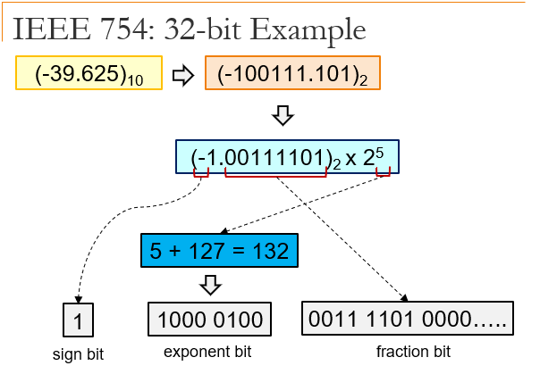

# MIPS

NOT: use nor

If condition, jump

$s0 < $s1  
Slt $t0, $s0, $s1  
bne $t0, $zero, dest

$s0 > $s1  
Slt $t0, $s1, $s0  
bne $t0, $zero, dest

$s0 <= $s1  
Slt $t0, $s1, $s0  
beq $t0, $zero, dest

$s0 >= $s1  
Slt $t0, $s0, $s1  
beq $t0, $zero, dest

# Pipelining

Read after Write  
Forwarding

To reduce stalls in loop (beq)

* Early Bird

Add an adder in Decode stage, use this value to decide, then modify forwarding using pipeline register

* Branch Prediction

Gambles, and does the instruction, if wrong prediction, flushes out

* Delayed Branch

Rearranges the instruction, to do while waiting for response, done by compiler

Processor Controls Summary

|  |  |  |  |  |  |  |  |  |  |
| --- | --- | --- | --- | --- | --- | --- | --- | --- | --- |
|  | RegDst | ALUSrc | MemTo Reg | Reg Write | Mem Read | Mem Write | Branch | ALUop | |
| Op1 | Op2 |
| R- Type | 1 | 0 | 0 | 1 | 0 | 0 | 0 | 1 | 0 |
| Lw | 0 | 1 | 1 | 1 | 1 | 0 | 0 | 0 | 0 |
| Sw | X | 1 | X | 0 | 0 | 1 | 0 | 0 | 0 |
| Beq | X | 0 | X | 0 | 0 | 0 | 1 | 0 | 1 |

Processor control uses Opcode to generate ALUop, passed to ALU CONTROL UNIT

ALU CONTROL UNIT uses ALUop and funct field to procude ALU Control

|  |  |  |  |  |  |
| --- | --- | --- | --- | --- | --- |
| Opcode | ALUop | Instruction  Operation | Funct Field  from MIPS | ALU  Action | ALU  Control |
| Lw | 00 | Load Word | XXXXXX | Add | 0010 |
| Sw | 00 | Store Word | XXXXXX | Add | 0010 |
| Beq | 01 | Branch equal | XXXXXX | Sub | 0110 |
| R-Type | 10 | Add | 10 0000 | Add | 0010 |
| R-Type | 10 | Subtract | 10 0010 | Sub | 0110 |
| R-Type | 10 | And | 10 0100 | And | 0000 |
| R-Type | 10 | Or | 10 0101 | Or | 0001 |
| R-Type | 10 | Slt | 10 1010 | Slt | 0111 |
| R-Type | 10 | NOR | 10 0111 | NOR | 1100 |

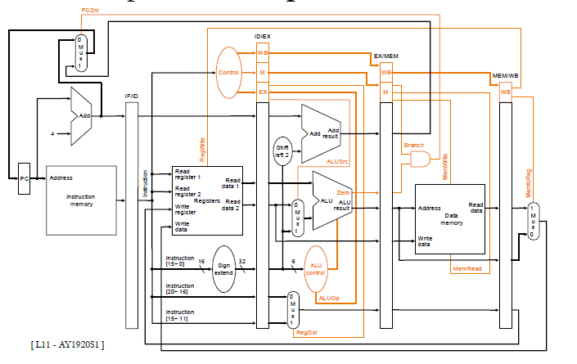

Last Mux, MemToReg 1 is above, 0 is below

|  |  |  |
| --- | --- | --- |
| MIPS Assembly Language | | |
| R - Type | Opcode[6] rs[5] rt[5] rd[5] shamt[5] funct[6] |  |
| Addition/subtraction | add / sub rd rs rt | Rd = rs + rt |
| And / or / xor / nor | And rd rs rt | Rd = rs [op] rt |
| Shift left / right logical | Sll rd rt shamt | Rd = rt << / >> shamt |
| Set less than | Slt rd rs rt | Rd 🡨0/1🡨rs < rt |
| I – Type | Opcode[6] rs[5] rt[5] immd[16] |  |
| Add Immediate | Addi rt rs Immd | Rt = rs + immd |
| Load / store word / byte | lw rt Immd(rs) | Load the word |
| Branch equal / not equal | Beq rs rt Immd | If rs == rt, go to pc + 4 + immd * 4 |
| J – Type | Opcode[6] address[26] |  |
| jump | J addr | JUMP to address |

General Purpose Registry

|  |  |  |
| --- | --- | --- |
| Name | Register  number | Usage |
| $zero | 0 | Constant value 0 |
| $v0 - $v1 | 2 – 3 | Values for results and  expression evaluation |
| $a0 - $a3 | 4 – 7 | Arguments |
| $t0 - $t7 | 8 – 15 | Temporaries |
| $s0 - $s7 | 16 – 23 | Program Variables |
| $t8 - $t9 | 24 – 25 | More Temporaries |
| $gp | 28 | Global pointer |
| $sp | 29 | Stack pointer |
| $fp | 30 | Flame pointer |
| $ra | 31 | Return address |

$at (register 1) is reserved for assembler  
$k0 - $k1 (register 26 – 27) are reserved for OS

|  |  |  |  |
| --- | --- | --- | --- |
| MIPS Assembly Language | | | |
| Category | Instruction | Example | Meaning |
| Arithmetic | Add | Add $rd, $rs, $Srt | $rd = $rs + $rt |
| Subtract | sub $rd, $rs, $rt | $rd = $rs - $rt |
| Add Immediate | addi $rt, $rs Immd | $rt = $rs + Immd |
| Data Transfer | Load Word | lw $s1, 100($s2) | $s1 = Memory[$s2 + 100] |
| Store Word | sw $s1, 100($s2) | Memory[$s2 + 100] = $s1 |
| Load Byte | lb $s1, 100($s2) | $s1 = Memory[$s2 + 100] |
| Store Byte | sb $s1, 100($s2) | Memory[$s2 + 100] = $s1 |
| Load Upper Immediate | lui $s1, 100 | $s1 = 100 * 216 |
| Conditional Branch | Branch on not Equal | beq $s1, $s2, 25 | if ($s1 == $s2) go to  PC + 4 + 100 |
| branch on not equal | bne $s1, $s2, 25 | if ($s1 != $s2) go to  PC + 4 + 100 |
| Set on Less than | slt $s1, $s2, $s3 | if ($s2 < $s3) $s1 = 1;  else $s1 = 0 |
| Set Less than Immediate | slti $s1, $s2, 100 | if ($s2 < 100) $s1 = 1;  else $s1 = 0 |
| Unconditional Branch | Jump | j 2500 | go to 10000 |
| Jump Register | jr $ra | go to $ra |
| Jump and Link | jal 2500 | $ra = PC + 4; go to 10000 |

